2.21: a) Equating Equations (2.9) and (2.10) and solving for v₀,
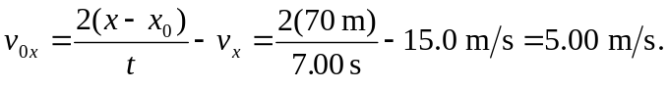
b) The above result for v_{0x} may be used to find
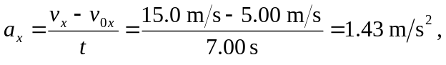
or the intermediate calculation can be avoided by combining Eqs. (2.8) and (2.12) to eliminate v_{0x} and solving for a_{x},
